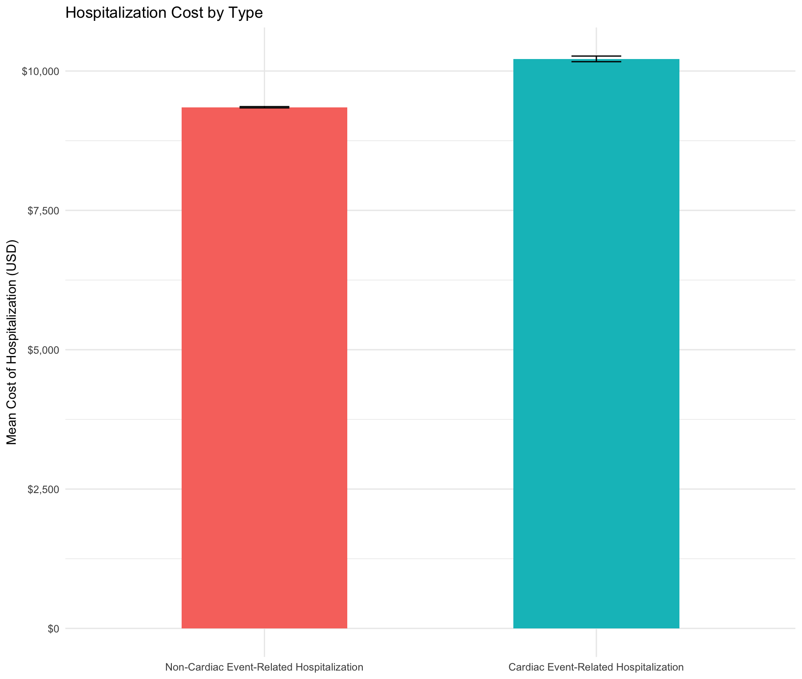
Figure 1: Mean Cost, Stratified by Hospitalization Type

